Time and product based cashback offer

# Objective

The objective of the task is to run cashback offer basis time and product id for both B2b and B2C users.

Details -

To run the offer user will set the cashback rule from the coupon code system >> Set cashback rule page.

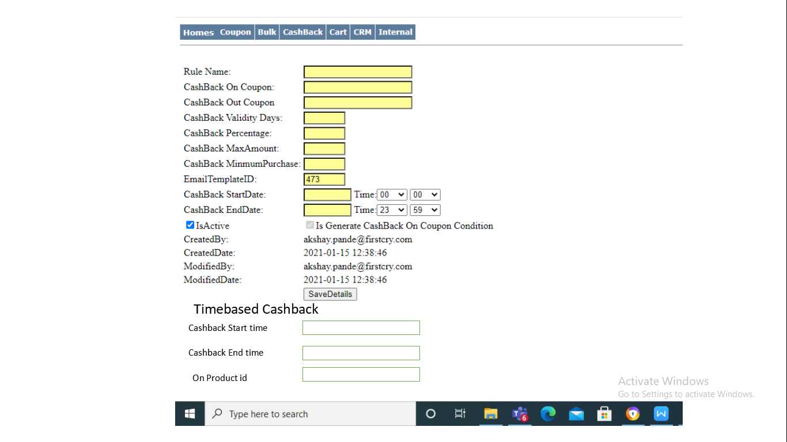

1 - Cashback start time - The user must select date greater than today’s date in the field.

2 - Cashback end date - The cashback end date should be more than todays date.

3 - On product id - The user will input product id on which the cashback will be generated. The user can input upto 20 product ids in the field.

Communication.

Once the offer is set from the cashback page, if the customers buys the product id mentioned in the list a email and sms will be triggered to the user.

The email and sms will have the cashback code that can be used on firstcry.

The calculation of cashback will be done for both B2B and B2C customers.

For B2B the data should be picked from the API shared with Marketing team.